How to register your interest to Volunteer on Eventing Volunteers
I’ve never signed up before, but want to register for 2025
Follow this link EventingVolunteers.Com and you will be taken to the below page.

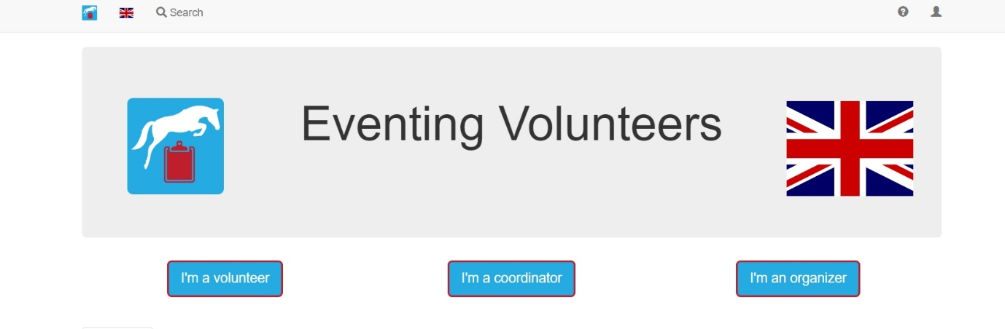

Ensure that there is a British Flag displayed. If not, select the small flag symbol on the top left of the page and select UK.

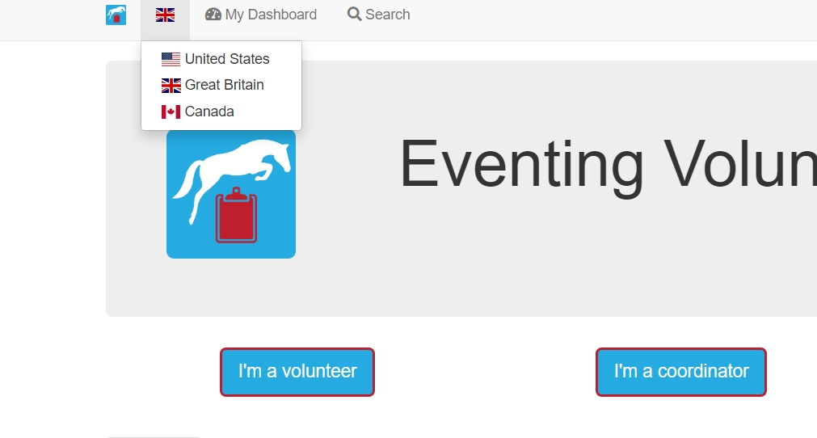
From here, click ‘I am a volunteer’ and you will be taken to the Sign in or Sign-Up page.
To sign up use the right-hand option. Please do not use the buttons to sign up with Facebook, Google, Outlook or Apple. Put in your details and create a password. You will be sent an email shortly after asking you to confirm your account.
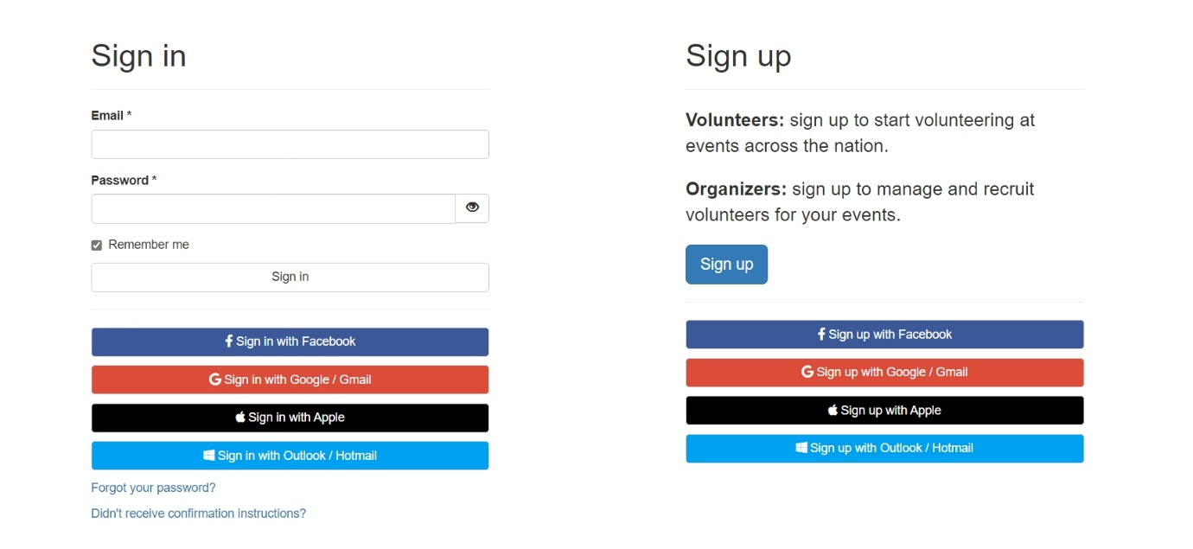
Once Signed up, you will be able to select Scone Horse Trials as an event to volunteer for shifts for under ‘upcoming events’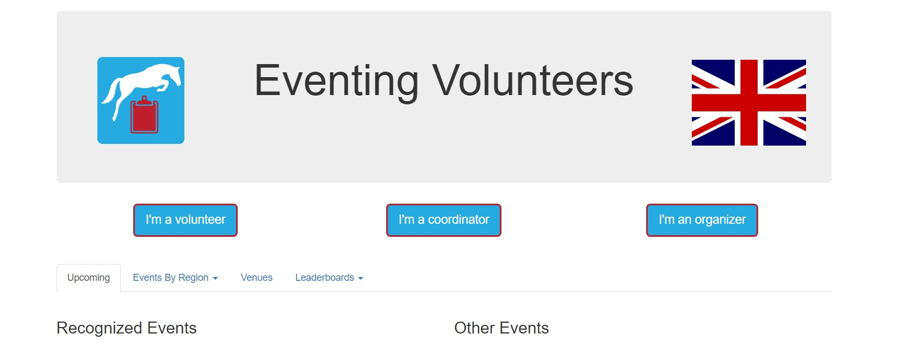
Once you have signed up for shifts, you will be able to view these and receive updates via your dashboard.
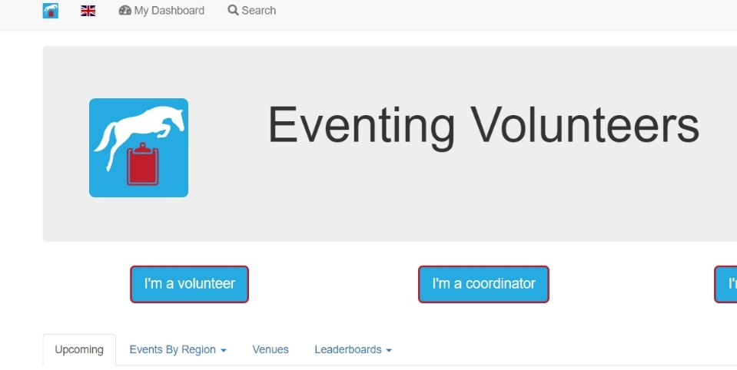

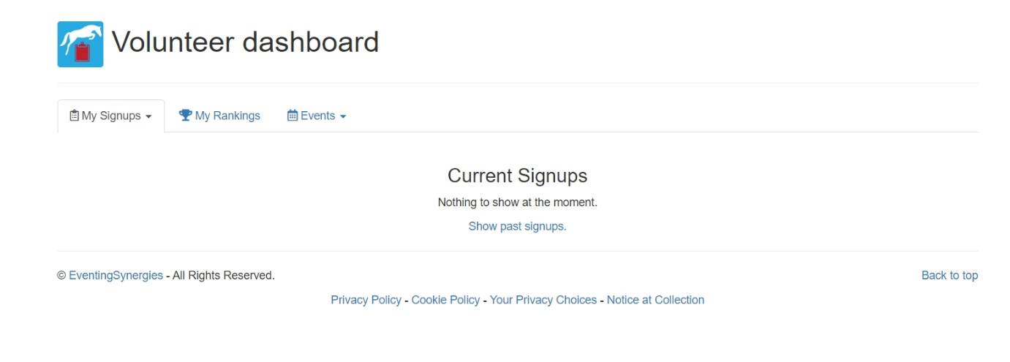

Now you are ready to register for shifts at Scone Palac International Horse Trials 2025 when available.

